 fc

**8th grade**

**2025-2026**

Syllabus

Science

**Dulles**

**Middle School**

Mrs. Henry

Contact Information!

Supplies



Email**: Gail.Henry@fortbendisd.gov**

**Conference: Wednesday & Thursday 3rd per.**

Room**: 500** School Phone**: (281) 634-7780**

You are expected to bring these materials to class EVERY DAY!

* 1 composition Notebook & 1 pocket folder

(Bring 1 extra if you can donate)

* Pencils/ Ink pen
* Glue sticks
* Colored Markers/Pencils
* District issued Laptop (Bring fully charged every day)- issued on Aug. 14th.

No personal PC’s allowed.

**Classroom Wishes**

We always need -Kleenex

-Glue Sticks

- Clorox wipes



**Weekly calendars are posted in student’s Outlook & Schoology**

**You are expected to behave in a respectful and courteous manner, as well as act in accordance with the classroom rules (listed below). My classroom will be maintained as a safe and successful learning environment for all of my students. Any disrespectful or harmful behavior which disrupts classroom learning will NOT be tolerated and WILL be dealt with accordingly.**

Course Expectations



Classroom Values

0



- Tuesday Tutorials 8:10-8:50 am

- The Zone will be available every Tuesday and Thursday 4:10- 5pm

(start date will be available soon)

1. **Respect:**

Please be respectful to yourself, your peers, and your teacher. Disrespectful actions or inappropriate behavior will result in disciplinary consequences.

1. **Initiative:**

When you come to class, please have all your materials and be ready to learn. **Taking initiative means you are** willing to do things without being told; find out what you need to know; keep going when things get tough; and you spot and take advantage of opportunities.

1. **Teamwork:**

The social sciences encourage discussion, debates, and group work. Please be willing to cooperate with your peers and participate in class assignments.

1. **Balance:**

You are responsible for completing your own assignments and schoolwork. I encourage you to effectively balance school demands and those of your personal life. An individual who lacks a school-life balance has built up school and home obligations, works longer hours, and lacks personal time.

**Absentee & Late Work**

If you miss an assignment while out, you must submit the completed assignment within the # of days you were absent. If you turn in after, late points will be deducted from your assignment grade. Please remember it is **your responsibility** to collect your work **the day** you return to class. (Check Schoology)

1st day late – Max 90%

2nd day late – Max 80%

3rd day late – Max 70%

4th day late – Max 60%

5th day late – Max 50%



**Textbook**

**Your online textbook is**

**SAVVAS and can**

**Be found in Clever.**



**Cellphones and Electronic Devices**: This is YOUR **WARNING!** cell phones and other electronic devices must be turned **OFF**. If you caught on your phone or electronic device, you will **NOT** receive an additional warning. ***There will be a call home, your AP will be notified, and the device will be taken away.***

**Plagiarism is defined as taking ideas and writings of another and passing them off as your own.**

**DON’T DO IT!**

Cheating/ Plagiarism

**Bathroom Policy**: Students are allowed to go to the bathroom after the first 10 min and before the last 10 min of class. **EXCEPT,** when I am actively teaching OR if someone is already out. However, please make sure you **sign out** **AND get a signed pass** before leaving my classroom. Knowing where you are and where you are going to be is a precaution for **YOUR SAFETY**.



**If you cheat or plagiarize, then you will receive a failing grade on your assignment, a phone call will be made to your parents, and the administration will be notified.**

**Tests, Exams and Quizzes:** During tests and quizzes, you will not be permitted to use the bathroom due to cheating precautions. If it is an emergency, please come to me and we will address the situation accordingly.

**Tardy Policy**: Students are to arrive **ON TIME** to class. If you are late you **MUST** have a **PASS.** If you are not inside my class by the end of the last tardy bell you **will** be marked tardy in SKYWARD. After your first tardy you will receive a verbal warning, after two you will receive a verbal warning and a parent phone call home, and after three you will be assigned lunch detention. If being tardy continues to be an area of concern further action will be taken to help you get on track.

Homework

GRADING

SCALE

Skyward

vs

Schoology



“This is science, you will have homework PERIODICALLY, please don’t OVERREACT!”

Students will login for collaboration, communication, assessment, submitting assignments and discussion boards. This is also where you can find all your course materials such as notes and assignments.

Progress Reports

3 weeks

Report Cards

9 weeks

A 90-100

B 80-89

C 70-79 F 69 and

below

Students and parents can login to view attendance, grades, schedules, and missing assignments. Communication from the teacher will be sent through skyward.

Homework, when assigned should take no more than 15-20 minutes of your time. If you are struggling to complete your homework, or find it is taking you longer please take the INITIATIVE to **get help.** Homework can be a great way for you to further self-assess your academic strengths and weaknesses!!

The following forms of assessment will comprise your total grade.

Major grades- 50%

Daily Grades- 50%

Any in-class assignment not completed will automatically become homework!

* **In-Class Assignments**
* **Quizzes**
* **Lab Investigations**
* **Tests and Projects**



**Tip:** Establish a routine for checking your student’s grades and assignments via Schoology & Skyward.

Dear Parents and Guardians,

I am very excited to teach your child 8th grade Science and I am looking forward to a very fun and engaging school year! Your student has been informed of the class syllabus. I would appreciate it if you would also review the course syllabus so that you are aware of what we will be doing in class throughout the school year. I will need for you and your child to sign, date, and return this syllabus by August 15th.

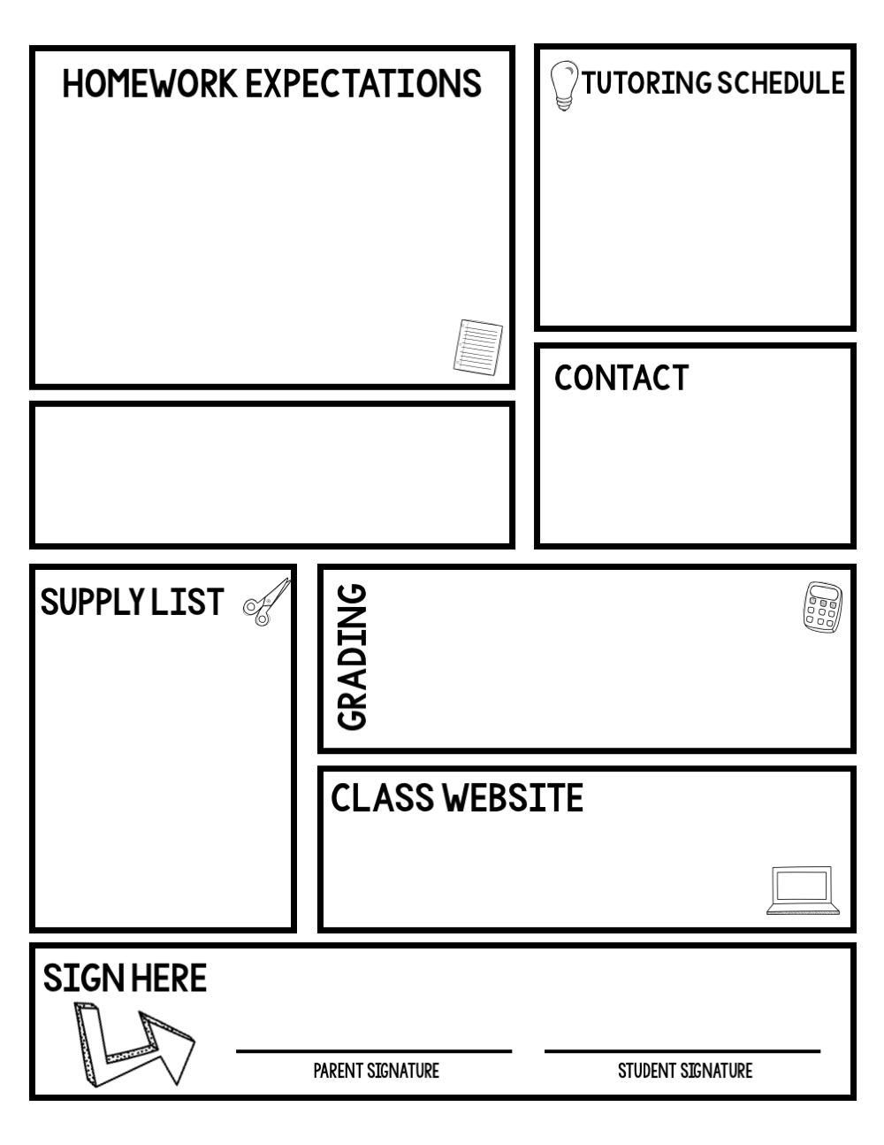

**DATE**